ED-This paper was impossible to completely understand. I encountered many sections where the meanings were unclear, due to grammar, references and inconsistency between/within sections. There were many problems with the same/similar terms being referred to in different (inconsistent) ways, when there should be a consensus as to the meaning; this further made accurate understanding impossible. I have made many ‘best guesses’ as to the true meaning, and many sections could not be edited because the fundamental meaning(s) was(were) not clear. With this in mind, although the result is a massive improvement, it is inevitable that some parts will have been misunderstood. I suggest careful review (and rephrase/clarifications, as appropriate) of this document to ensure meanings are as intended. Best of luck with your future research.

An Efficient Matching Scheme for Information Dissemination for Sensor Networks

Status of This Memo
This memo provides experimental information to the Grid community regarding implementation issues for the Information Dissemination working group. It does not define any standards or technical recommendations. Distribution is unlimited.

Copyright Notice

Copyright © Open Grid Forum (2007). All Rights Reserved.

Abstract
In the ubiquitous environment, sensor network technologies have advanced for collecting information of the environment. With the rapid growth of sensor network technology, it is necessary and important to share the collected sensor data with diverse users. In order to provide dissemination of sensor data, we design an information dissemination system using an independent disseminator between provider and consumer.
This document describes how we designed the information dissemination system using one of the possible dissemination patterns for sensor networks, and an efficient matching algorithm called CGIM (Classed Grouping Index Matching) which employs a dynamic re-grouping scheme.

Table of Content

Abstract 1
1. Introduction 3
2. Related works 4
2.1 Integration of sensor network with Grid 4
2.2 Information Dissemination 4
2.3 INFOD Standard in OGF(Open Grid Forum) 5
3. ARROW Architecture 6
3.1 Overview of ARROW 6
3.2 Interface & Processing 7
3.3 Information Dissemination Architecture 8
4. Matching algorithm for Information Disseminator 10
4.1 Event detection model 13
4.2 The grouping of predicates 13
4.3 CGIM (Classed Group Index Matching) algorithm 14
5. Performance evaluation 15
5.1 Performance comparison 15
5.2 Impact of grouping 18
6. Conclusion 21
Author Information 22
Intellectual Property Statement 22
Full Copyright Notice 22
References 23

Introduction

In a ubiquitous environment, with rapid advances being made in sensor technology, ubiquitous sensor networks (USNs) have emerged to collect a lot of information of the physical world. USNs are characterized as an interconnection of many resource-constrained sensor devices with sensing capability, data processing, and wireless communication capabilities. Sensor nodes sense various factors in their environments, such as temperature, humidity and pressure variations.
Ubiquitous sensor networks are increasingly being deployed in many important applications such as healthcare monitoring for patients, weather or disaster monitoring and forecasting, tracking of goods and manufacturing processes, safety monitoring of physical structures and smart homes and offices.
In USN environments, a large number of sensor devices are deployed and aggregated over a wide area for data acquisition and processing. However, USNs have limited sensing capability, processing power, and communication bandwidth. As managing, processing and storing a huge variety of sensor data are necessary in those environments, it is very important to share geographically distributed computing resources. Moreover, requirements of ubiquitous S/W systems integrating USN are becoming complex with challenging issues such as system scalability, high volume data handling, employing SOA(Service Oriented Architecture) over Web technology, semantic matching, publish/subscribe (denoted to pub/sub) based dissemination, and fault tolerance.
Furthermore, the current Web paradigm is shifting from manual human-to-machine interaction to autonomic machine-to-human interaction. As Web 2.0 technology including Web Services, focuses on real-time business services, the current S/W architecture, especially real-time event processing architecture, requires shifting to a new paradigm in order to trigger events, create contents, and push (information) messages. Thus, handling of high volume sensor data in the new Web paradigm is an interesting problem.
In recent years, Grid computing has evolved to coordinate sharing of distributed and heterogeneous resources and to support a very powerful way of managing, processing and storing the huge amount of data. Grid (combination of computational Grid and data Grid) provides distributed computational resources to solve large-scale problems as well as seamless access to the storage resources and efficient managing and transmission of a large amount of distributed data [8].
By integrating the sensor network with Grid, the sensed data can be stored, processed and accessed more efficiently. To utilize the sensor data efficiently for real-time business, an information dissemination service is a very necessary component. And there are very few researches that integrate the Sensor-Grid and Information Dissemination mechanism.
In this document, we have proposed an architecture called ARROW (Adaptive and Reconfigurable ResOurce management for Wireless sensors using Grid technology), a combination of Sensor-Grid and Information Dissemination to selectively disseminate the sensor data to subscribers. Also we have presented a matching algorithm, called CGIM (Classed Group Index Matching) which finds matched subscriptions efficiently for the information dissemination system. Our CGIM algorithm focuses on the disseminating system corresponding to OGF (Open Grid Forum) INFOD-WG (INFormation Dissemination Working Group) standard [8-12] and disseminates sensor data employing OGSA-DAI(Open Grid Services Architecture Data Access and Integration) on Grid [13]. This work targeting the ubiquitous healthcare system focuses on gathering the patient’s state (blood pressure, temperature, and pulse rate) from bio-sensors, aggregating data from sensors to deliver to sink node via USN, detecting events and disseminating useful information to medical staffs, nurses, and doctors who subscribed.
The document is organized as follows: Section 2 briefly reviews related works. Section 3 describes our proposed ARROW architecture. Section 4 presents our matching algorithm to find event data in the information dissemination system. Section 5 shows the result of performance experiments of our matching algorithm and finally Section 6 concludes the document.

Related work

We have designed the information dissemination system integrating the sensor network into Grid and information dissemination mechanism. So, we reviewed the research around sensor networks with Grid and information dissemination as related work.

Integration of sensor network with Grid

Recently, research efforts are beginning to study the integration of wireless sensor networks and Grid computing. Researchers are studying ways to integrate sensor networks into e-Science Grid computing applications.

The Discovery Net provides a Grid based framework for developing and deploying a Knowledge discovery service to analyze data gathered from distributed high throughput sensors. This architecture is proposed for building knowledge discovery applications based on the Grid environment. Discovery Net infrastructure is based on the Kensington system [10]. The Discovery Net [1] infrastructure extends its architecture to enable its functions in the Grid environment. Discovery Net infrastructure is designed for interacting with protocols such as data transfer protocols, security, and discovery process workflow protocols to integrate with other infrastructures such as OGSA.
CIMA (Common Instrument Middleware Architecture) [2] project aims to ”Grid enable” instruments and sensors to integrate with the Grid environment. But there is the limitation that the middleware architecture is too complex to be implemented on simple sensor devices with low computational and processing capability.
SPRING(Scalable Proxy-based aRchItecture for seNsor Grid) [3-4] provides Grid based Architecture for integrating with the wireless sensor network and Grid environment. SPRING architecture provides a WSN(Wireless Sensor Network) Proxy which is an interface between the sensor network and the Grid. It can expose sensor resources as Grid services and translates the data of sensors from its original format to an OGSA format such as XML. The WSN Proxy integrates connectivity between the wireless sensor network and Grid network. The New Wireless sensor network can be integrated with the sensor Grid by using the WSN Proxy so that the Sensor Grid can be extendable and scalable. The WSN Proxy provides various services such as scheduling, security, availability, and QoS in the wireless sensor network environment.
SGSIA(Secure Grid-Sensor Integration Architecture) is proposed as a secure and scalable architecture for integrating a resource constrained sensor network into the Grid. In the SGSIA project, the architecture has three important tasks. First, at the sensor node, the raw data is filtered to reduce the overall data transmitted to the Grid. Second, forward the query to the sensor network efficiently. Third, provide a secure communication channel between the sensor network and Grid [5].

Discovery Net architecture is efficient and can deliver good performance for targeted applications; however, it is not flexible or scalable. CIMA and SPRING do not address balancing of resources, Grid query caching for optimizing the overall number of queries sent to the USNs, and access to multiple USNs and data filtering mechanism in network stack for reducing the volume of data generated on the sensor network. We have designed architecture that integrates the sensor network with the Grid using ARROW architecture by considering these problems.

Information Dissemination

There are high demands in information dissemination systems recently on ubiquitous society as real-time business services may handle events triggered from sensed data, evaluate the events, process information, and eventually deliver the information to consumers. Several researchers propose models of information dissemination systems such as SDI system [6] and Rebeca [7].
In the SDI System (Selective Dissemination of Information System), the model integrates managing, and accessing profiles and disseminates information that matches the user’s profile. The architecture indexes the profiles from all users into a multi-level index structure using XML. It uses similarity-based construction of profiles and similarity-based matching between incoming documents and profiles. The architecture builds an index that relies on collaborative filtering and supports documents in XML to respond to current needs of system dissemination [6].
The Rebeca project provides disseminating dynamic information for the mobile clients. Rebeca is publish/subscribe middleware that can help disseminate dynamic information to mobile consumers. The Rebeca platform uses content-based subscriptions to give subscribers fine-grained control over the content they receive. And it enables implementation of intelligent filtering mechanisms for relieving the infrastructure load and mobile clients [7].

However, these researches of information dissemination system do not consider integrating sensor networks and Grid. So we designed an information dissemination system using the INFOD standard in ARROW architecture.

INFOD Standard in OGF(Open Grid Forum)

Our disseminating system is designed using one of the possible patterns described below. The designed architecture is implemented for u-health care.

There are possible five entities for system design as follows:

- Registry – Each component such as publisher (Application Specific Service), consumer (doctor), or disseminator should register to the registry with their subscription. Subscription has some information of components such as name, address, and details what a doctor wants to receive. The registry provides storage, management of the subscriptions and distribution of the subscriptions to the disseminator(s) for disseminating the sensor data to selected consumers.
- Consumers – Consumers (doctors) must register with the registry and receive selected patient data as defined through subscription.
- Publisher – Publisher publishes status data and propagates to the information disseminator.
- Disseminator– Disseminator receives the consumer’s and publisher’s information from the registry and disseminates the status data according to the information. In our architecture, the disseminator can send the emergency data to the consumer immediately when event (emergency) data is collected.
- Subscribers– Subscribers support translating consumer/publisher’s information format from web page format to a suitable registry format.
- Subscriptions – Subscriptions are used to specify consumer’s interests.

The standard introduces three disseminating patterns as follows:

- Basic pattern 1 –This pattern shows three entities as registry, publisher, and consumer. Publishers request to the INFOD registry to find matching consumers. After selecting consumers, the publisher sends publications to the consumers.
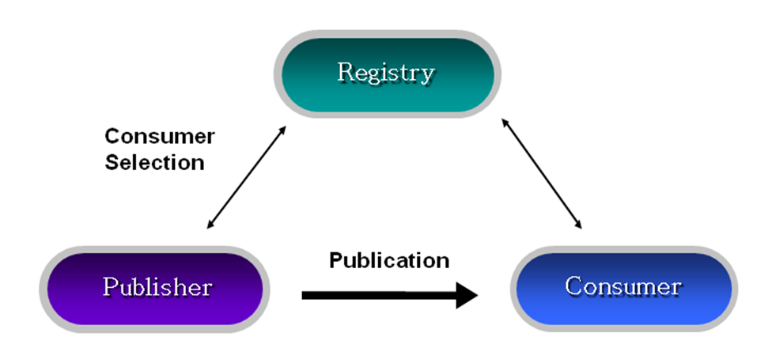
(Figure 1) Basic pattern 1
- Basic pattern 2 –In this second pattern, the consumer filters messages based on publisher’s properties. They request to the INFOD registry to find publishers.

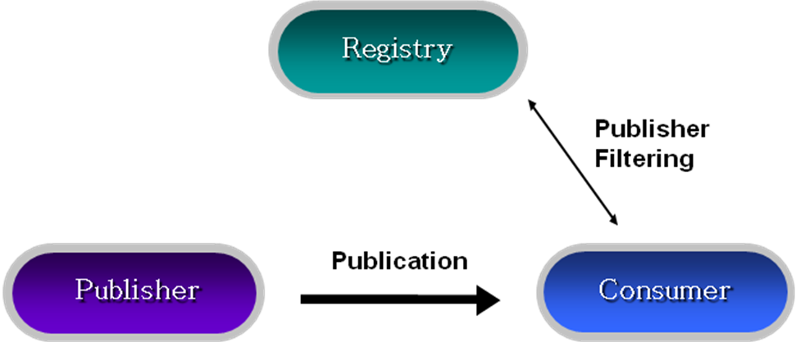

(Figure 2) Basic pattern 2
- Single Disseminator –This pattern includes a disseminator to pattern 1 and 2. In pattern 3, a disseminator provides sending events to a number of consumers. The disseminator matches the subscriptions of consumers to information of publishers and sends the messages to the selected consumers.

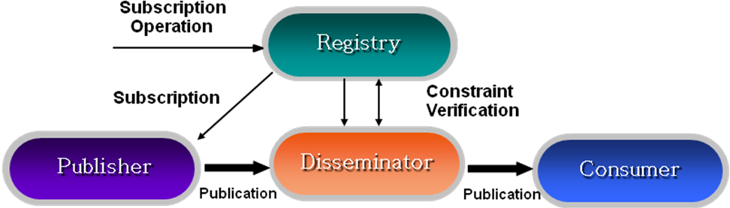

(Figure 3) Single Disseminator

Our experiment targets pattern 3. In the architecture, five entities - sensors or Application specific service as publisher, doctors as consumers, subscriber, registry, and disseminator – are modeled. This is discussed in detail in section 3.

ARROW Architecture

Overview of ARROW

Our architecture has two parts as processing part and disseminating part. We propose our overall system called ARROW (Adaptive and Reconfigurable ResOurce Management for Wireless sensors using grid technology) which consists of “Interface & Processing” and “Information Disseminator”. We will present them in detail in section 3.2 and section 3.3 as shown in figure 4.

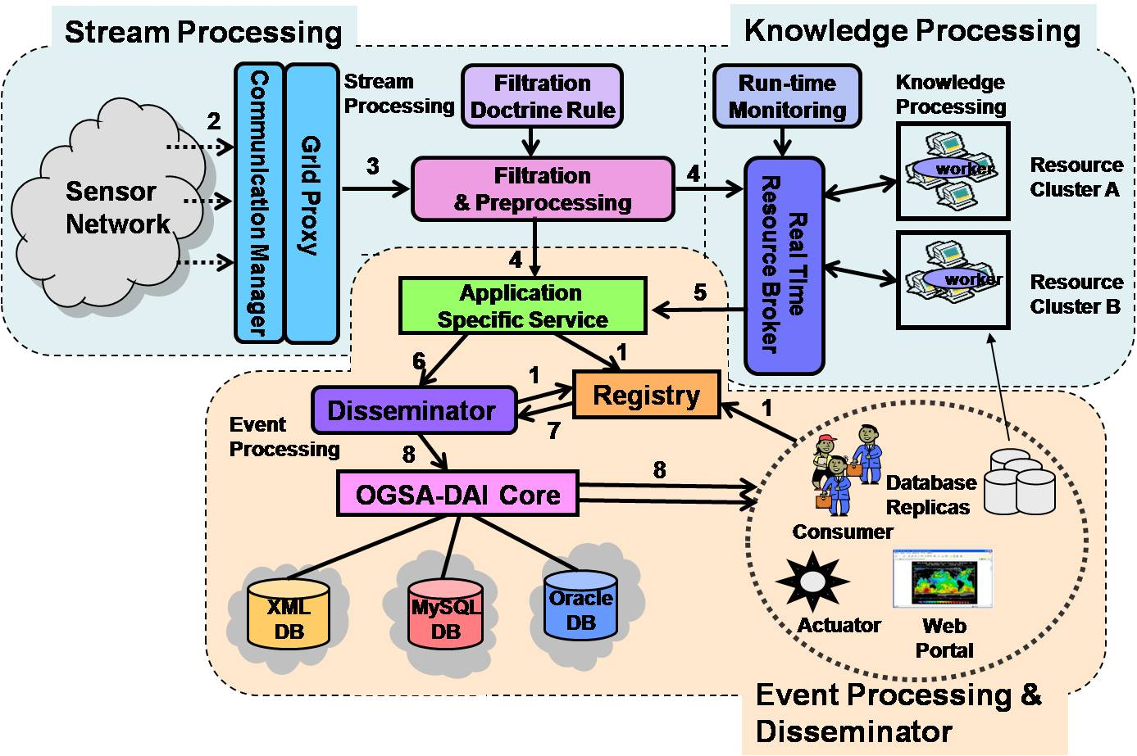
(Figure 4) The ARROW architecture

Interface & Processing

Interface & Processing Architecture

The Interface & Processing is designed for collaboration with sensor network and Grid. The raw data can be processed and filtered using Grid resources in this architecture. The Interface & Processing has three components. The definition of each component of the Interface & Processing is explained as follows:

- Communication Manager (CM) –It communicates to the wireless sensor devices or wireless sensor gateway. It works as a bridge between wireless entities and mitigates the effect of frequent network disconnection, security and fault recovery. CM also employs an important algorithm to retrieve data from wireless sensor devices. After collecting the data from the sensor devices, CM sends it to the Filter Manager (FM).
- Filter Manager (FM) –FM collects the sensor data and requests for resources to RM (Resource Manager) to aggregate the sensor data and to filter the data using an event doctrine file which the administrator defined.
- Resource Manager (RM) – RM seamlessly serves dispersed Grid resources to FM for filtering sensor data. RM monitors the resource workload to adapt the variations in the resource performance and application requirements.

This system flow as shown in figure 5 is explained step by step as follows;

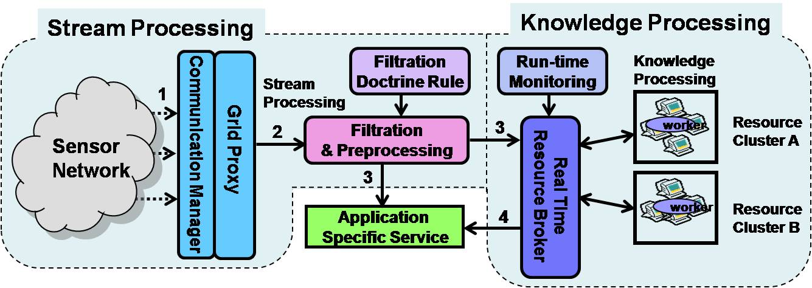
(Figure 5) Architecture of processing interface

Step 1: Sensors sense data from the environment.
Step 2: CM gathers the data and propagates to FM for pre-process and low level filtration.
Step 3: FM collects the sensor data and requests resources from the RB (Resource Broker) and application specific service. RB aggregates the sensor data and filters the data using an event doctrine file which the administrator defined.
Step 4: RM sends data to Application Specific Service to disseminate the data to users using the Information Disseminator.

Information Dissemination Architecture

As mentioned in section 1, the INFOD specification is well explained in [12] by illustrating use cases; NextGRID Graphical Animations use case, car dealer use case, and Sensor Networks use case. Our implementation plugging the one of the Data Grid technology, OGSA-DAI, a widely used tool, is discussed in the following subsections.

OGSA-DAI

OGSA-DAI [13] handles data resources, such as flat file, relational or XML-databases, to be accessed via stateful web services. It also allows data to be queried, updated, transformed, and delivered. More detailed advantages of OGSA-DAI are indicated as follows;

- We don’t need additional code to connect to a data base or for querying data. OGSA-DAI supports an interface integrating various databases such as XML databases and relational databases.
- OGSA-DAI provides three basic activities that are querying data, transforming data, and delivering the results in sequence. OGSA-DAI can support not only querying and transforming but also delivering using ftp, e-mail, and push services.
- OGSA-DAI allows users to develop additional activities. This aspect supports the system to be scalable, and becomes powerful means to use the data resource in various ways.

From the above advantages, it is clear that use of OGSA-DAI for information dissemination in Grid environment makes the overall system efficient.

Information Disseminator System Flow

Following is the information disseminator system components as shown in the figure 6 ;

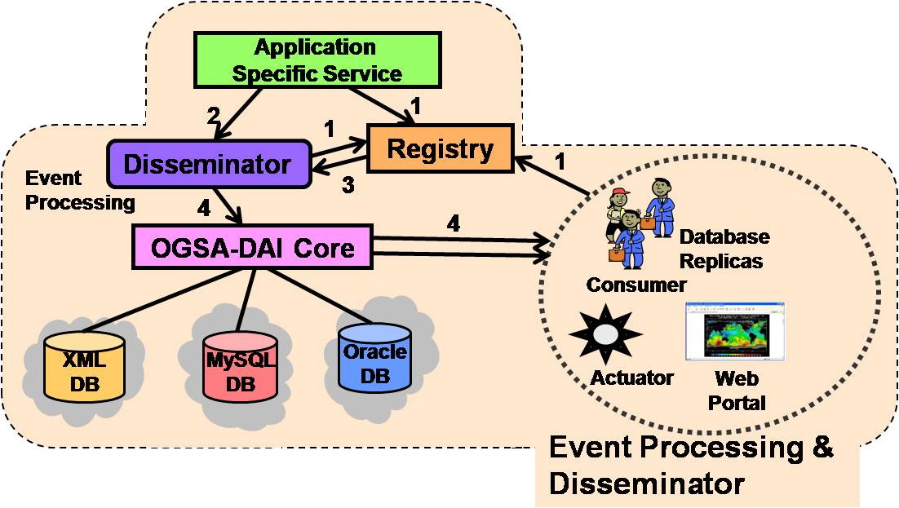

(Figure 6) Information disseminator components

Step 1: Each entity should register its information to the registry.
Step 2: Application specific service sends the processed data to the disseminator.
Step 3: Registry can manage, store subscription of each entity and distribute the information to disseminator(s). Disseminator can distribute sensor data to users efficiently using the information
Step 4: Disseminator detects event data for immediately delivery and schedules time based data for regular delivery according to the consumer’s subscriptions. It also stores sensor data to heterogeneous and distributed storages accessing uniformly using OGSA-DAI.
The figure 7 explains detailed steps for the Information Dissemination system.

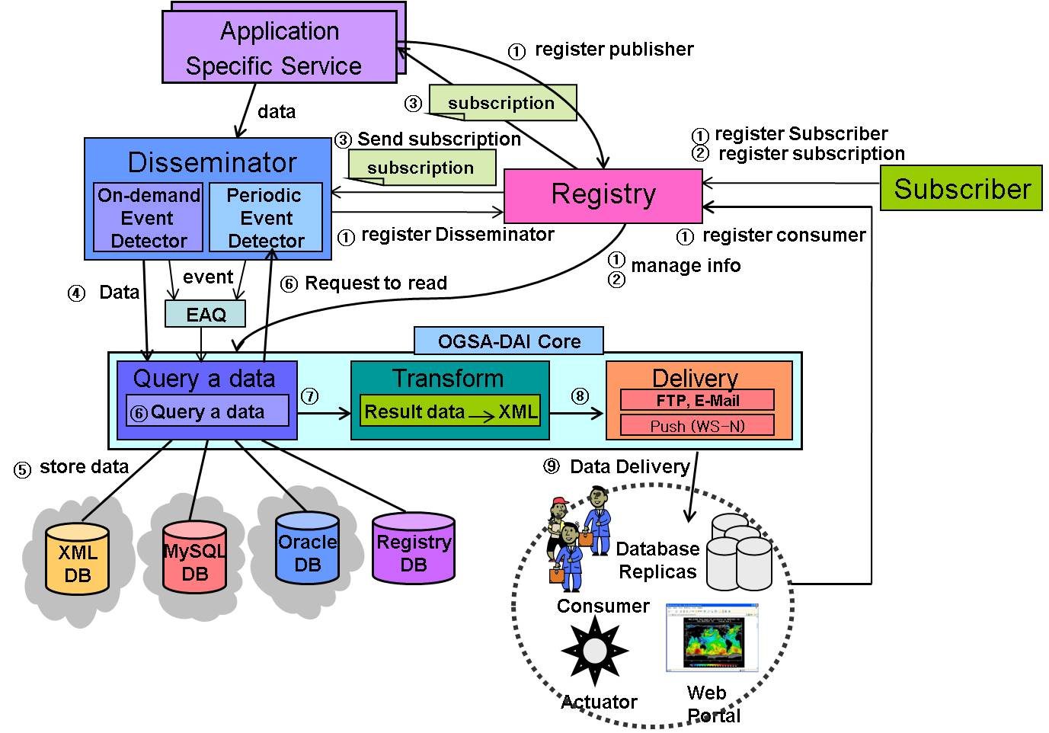
(Figure 7) The Information dissemination system flow

➀ Components of the information dissemination system (such as Application Specific Service, consumers, disseminator) register their information to the registry.
➁ Consumer send the subscriptions which include consumer’s interests to the registry using subscribers. Registry stores the information to the OGSA-DAI.
➂ Registry sends subscriptions to disseminator.
➃ When sensor data reaches to the system from “Application Specific Service”, disseminator detects whether the sensor data is an event data or not. In our model, the subscription allows predicate to have a single condition or multiple conditions. If the predicates include single condition the system processes step ➄ and step ➆ directly. If the predicates include multiple conditions, the event is sent to the EAQ(Event Aggregation Queue) which aggregates multiple events to make a single event(i.e. doctors may want to see patient’s status when blood pressure is abnormal and heartbeat rate is high in the same period.)
➄ Before disseminating sensor data to consumers, disseminator stores sensor data.
➅ When a predicate includes single condition, Periodic Event Detector determines dissemination schedules using consumers subscriptions, and requests data queries to the OGSA-DAI. In the case of the predicate with multiple conditions, if enough events are stored in the EAQ, the disseminator proceeds step ➄ & ➆.
➆ Disseminator requests to transfer the data to XML format using ‘perform document’.
➇ OGSA-DAI delivers the data to various consumers using FTP, E-mail or Web services Notification(WS-N) protocols.

Matching algorithm for Information Disseminator

Several researchers proposed event matching algorithms for pub/sub(publish/subscribe) to find events using the matching mechanism. In the algorithm [14], the authors propose a scheme using the tree structure of predicates. They construct a tree and match data by traversing from root(attr1) to sub-nodes(attr2, attr3..) as shown in the figure 8. In the figure, ‘*’ represents a matching condition that means all values are acceptable. When the data reaches the last node, the target subscriptions eventually are matched. The figure 9 shows an example using data=<1,2,3,8,2> with the matching algorithm. The subscription ‘I’<1,2,3,*,2> exactly matches to the data and becomes an event to the subscriber.

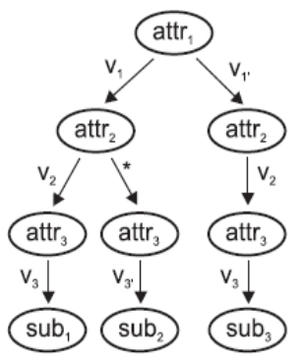
(Figure 8) matching procedure using subscription tree
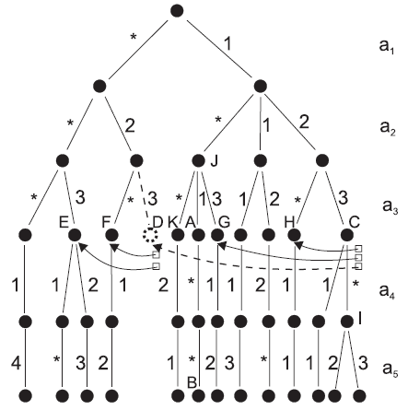
(Figure 9) layered predicates construction

The algorithm in [15] triggers events using semantic mechanism in the EAI (Enterprise Application Integration). Figure 10 shows creating events as “on-to-one”, “one-to-many”, “many-to-one”, and “many-to-many”.

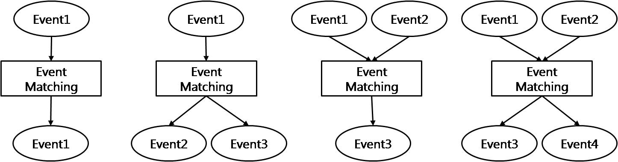
(Figure 10) Patterns of information matching in EAI

After triggering new events, COBDD (Colored Order Binary Decision Diagram) represents their matching procedure as shown in figure 11. Figure 12 shows a matching algorithm using OBDD(Order Binary Decision Diagram) for instance x∨(y∧z). The COBDD can be extended to OBDD as shown in the figure 11. They separates x∨(y∧z) into two predicates, C(x)∨O((y∧z)). Predicate C and O are different so that they can be combined to one by using COBDD. It results in 0(not matched) or 1 (matched).

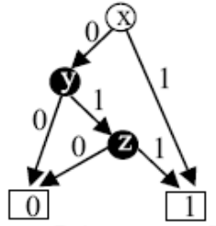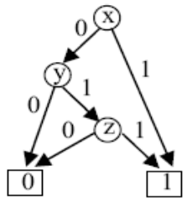
(Figure 11) x∨(y∧z) using COBDD (Figure 12) C(x)∨O((y∧z)) using OBDD

Another algorithm in [16] uses group of predicates to reduce matching time, assuming that subscriptions may have many identical predicates. The proposed scheme reduces resource consumption and matching time efficiently, while redundant sequential matching wastes computational resources. As shown in figure 13, the grouped index of predicates is used to search subscriptions joining predicate id and subscription id.

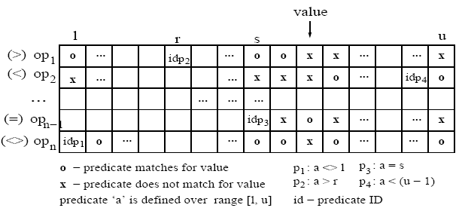
(Figure 13) Grouped index of predicates

The forwarding algorithm in [17-18] provides an efficient mechanism that matches corresponded predicates using attribute Indexing and Grouping as shown in the figure 14. Each predicate can include multiple attributes. The algorithm groups the predicates using attributes and operators of predicates, and the values of predicates are aligned into columns. The figure 15 shows the indexed attribute and architecture of the algorithm in detail. If sensor data matches with attribute “Quantity”, then it matches operators. After choosing an operator, it matches values of predicates sequentially.

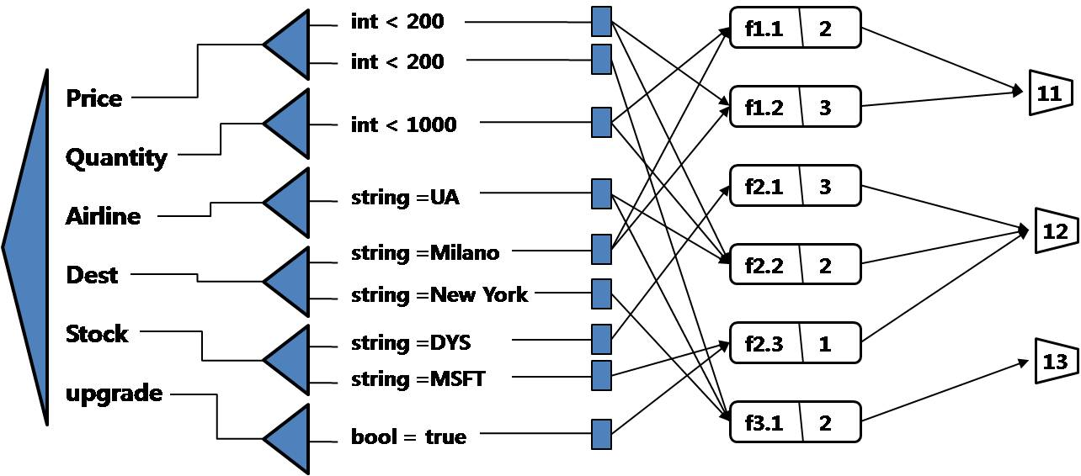

(Figure 14) Forwarding algorithm

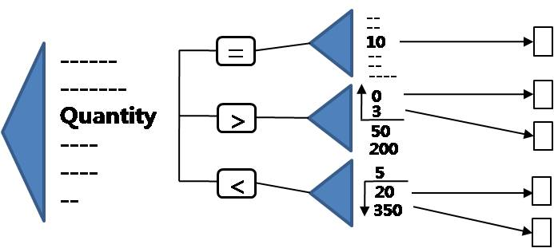
(Figure 15) Example of integer constraint Indexing

These algorithms result in a certain value, when the predicate of the subscription matches a specific constant. This condition can be resolved simply using tree based sequential matching as solved in [14-18]. However, if predicate’s condition requires certain range that consumers (doctors and nurses on the u-Healthcare system) expressed their interests into a range(i.e., 35<body temperature<37), then the matching problem becomes harder and more difficult to apply above techniques to trigger events. As patient states are changed continuously within a certain range(min, max) like body temperature and heartbeat, each classified consumer will require events in various ranges to safely take care of patients. So, ranged predicates are more efficient in describing consumer’s interests. Furthermore, the ranged predicate has several conditions of equivalence, subset, or intersection as shown in figure 16. In order to match efficiently to this situation, we propose a novel scheme called “Classed Group Index Matching (CGIM)”.

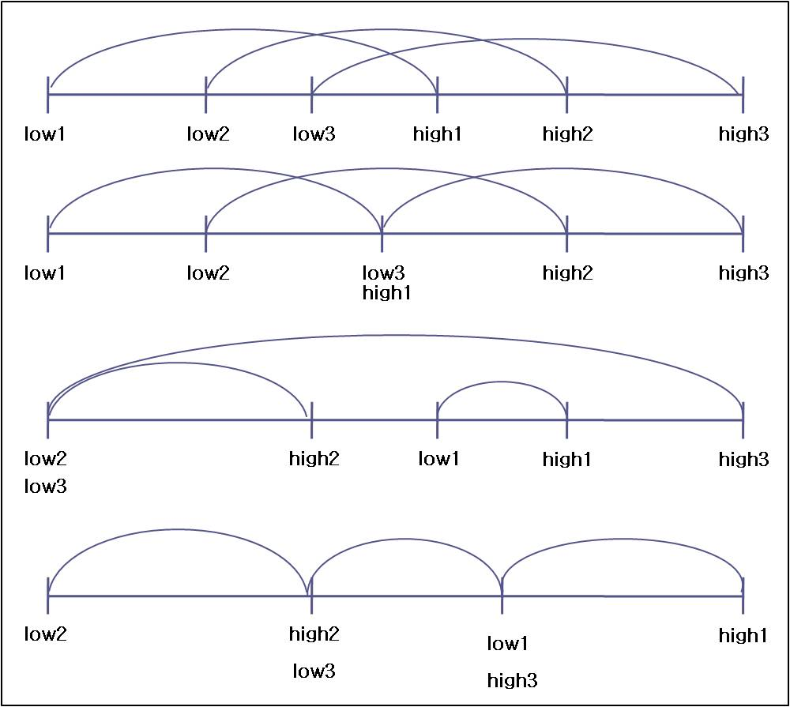

(Figure 16) Ranged predicates on u-Health event processing system

The specific feature challenges of the proposed system are as follows:
1) The information dissemination (denoted to Info-D) system should send sensor event messages to consumers directly when triggered, and deliver them every period subscribed.
2) The Info-D system should support several types of data such as blood pressure, temperature, pulse, or electrocardiogram in a u-Health environment.
3) The Info-D system should allow subscribers to describe two ranged predicates, (low_threshold_value< observed_data < high_threshold_value) and (low_threshold_value>= observed_data, high_threshold_value=<observed_data)
4) The Info-D system needs to be processed efficiently to handle a large number of subscriptions.

Event detection model

We designed the event detection model showing that detection of event is triggered by period or on time using BDD(Binary Decision Diagram). Sensor data not only includes the simple sensed value but also a department of the hospital such as Circulatory organ, Digestive organ, Respiratory organ, and kidney organ (denoted to p, q, r, s, respectively) and event type such as blood pressure, temperature, blood pressure (denoted to t, u, v, respectively shown in figure 18). In the figure 17 showing our BDD model, there are four types of nodes to find which data belongs to the range of predicates. Node x represents a minimum threshold value of the range and node y for maximum threshold value of the range in a predicate of the subscription. Event triggering, which is shown in the figure 17, needs to match sensed data to all predicates of subscriptions. This causes complexity on matching in the time and space domain, so we need an efficient matching algorithm that considers various types of subscriptions requested by many subscribers such as nurses, staffs, and doctors. Therefore, the following sections, 4.2 and 4.3, introduce our effort in designing an efficient matching algorithm for pub/sub systems.

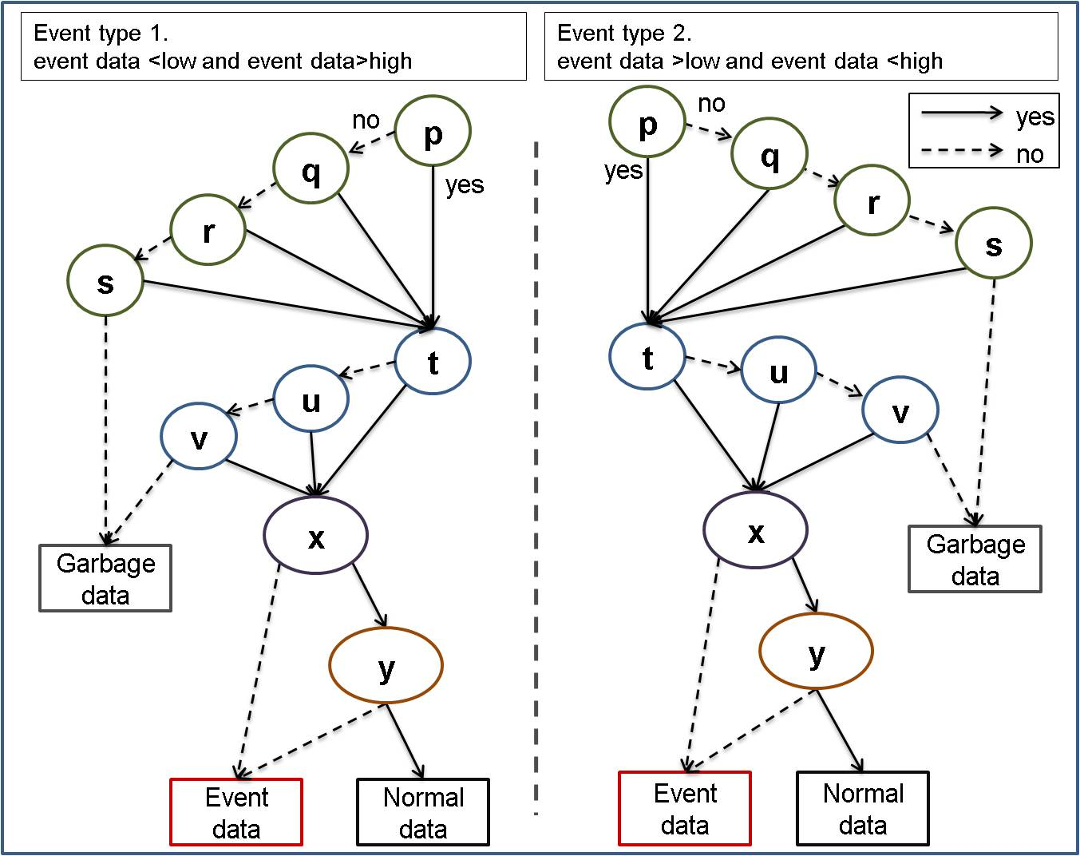
(Figure 17) Simple matching BDD model

The grouping of predicates

Subscriptions are composed of consumer’s personal information and predicates which show consumer’s requirements. Each predicate, P, consists of five elements such as P={event_type, N, op, mPV, MPV}, where the ‘event_type’ is detail event name, ‘N’ is the count of predicates,(i.e. ‘1’ for single data matching with mPV and MPV, and ‘2’ for two sensed input data to match mPV and MPV at the same time. The ‘op’ represents an operation such as “<<”, or “<>”. Also, mPV and MPV stand for minimal threshold value of the predicate and maximum threshold value of the predicate, respectively. The Information Dissemination system in the ARROW supports various expressions of predicates. First, “(mPV< data < MPV)” is used when consumers want to know normal patterns of sensed data as shown in the figure 18-(a). Second, “(mPV>data || MPV<data)” is used when consumers need to receive unusual states of the patient as shown in the figure 18-(b). Third, “(mPV> data1 && MPV<data2)” is used to support for couple of sensor data observed at the same time such as blood pressure as shown in the figure 18-(c).
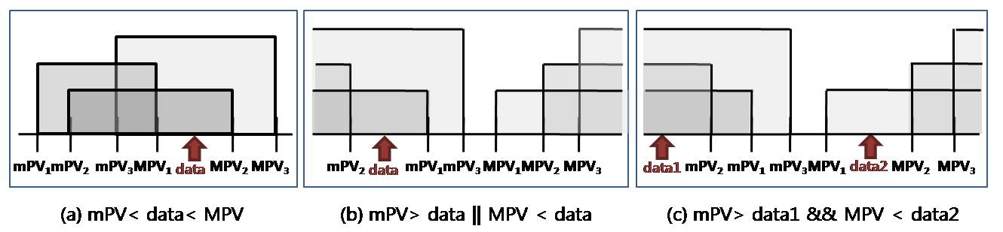
(Figure 18) various expression cases of CGIM

As we discussed in section 4.1, data which should be delivered on time will be matched to all predicates of subscriptions exactly. We employed the grouping scheme to reduce overhead in matching as shown in figure 19. First we grouped all minimal threshold values of predicates from all subscriptions denoted to mS for the set of mPVs, i.e. mS={mPV₁,mPV₂…..mPV_{i}} and MS for the set of MPVs, i.e. MS={MPV_{1,}MPV₂....MPV_{i}}. The figure 20 describes a grouping technique of predicates in detail.

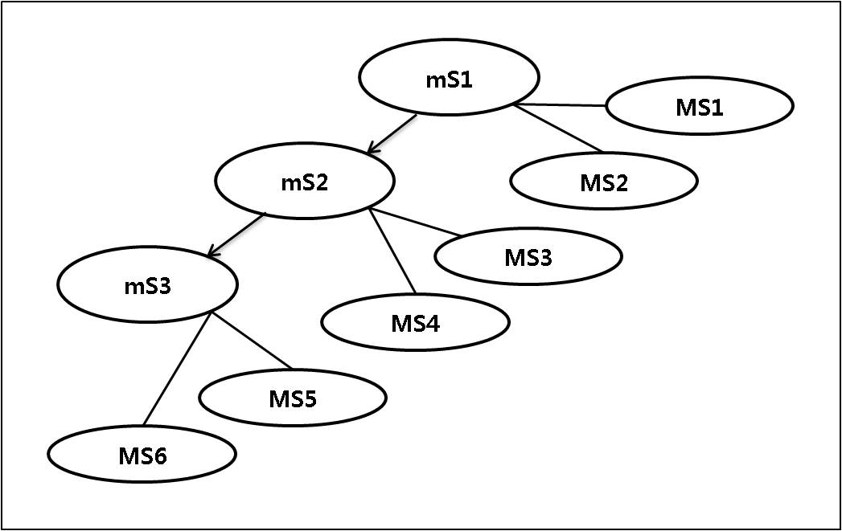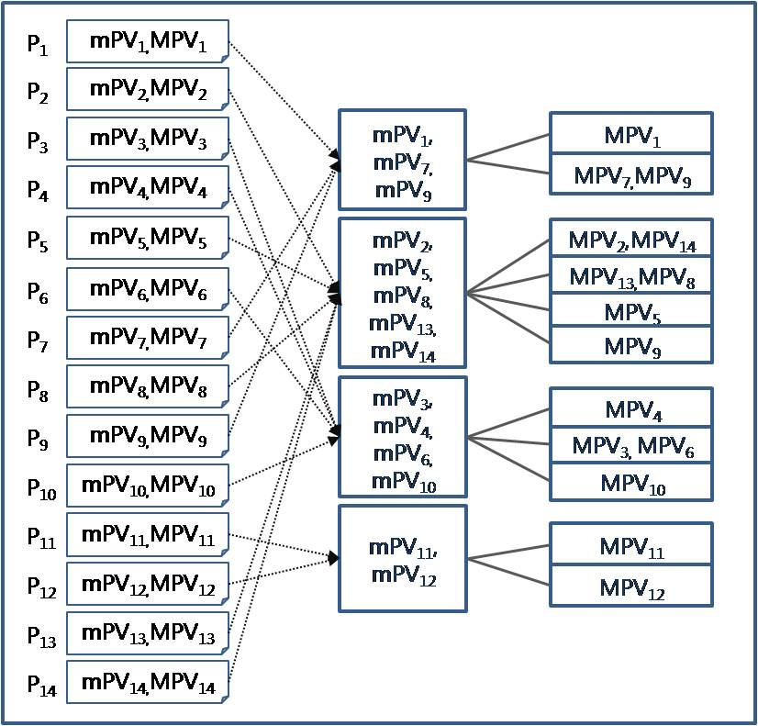
(Figure 19) Concept of grouping tree (Figure 20) Grouping predicates with subgroups

CGIM (Classed Group Index Matching) algorithm

In this section, we explain the procedure of our matching algorithm with the figure 21. This mainly focuses on grouping for ranged subscriptions rather than other issues such as detail indexing schemes, and memory management for data handling. General steps of CGIM are as follows. First, coarse level grouping partitions mS and MS among all subscriptions into small groups explained in section 4.2, which is done at the system initialization. Second, dynamic fine level grouping makes sub-partitions from the selected group based on statistical distribution of the subscription, and compares sensed data to maximum mPV. If it matches, then comparison with MS within the same predicate’s ID as mS is tested. This step produces feasible candidates, which is not enough to be the final predicate, as each ranged predicate can not be matched to the set, mS and MS. So, third, an exact matching step is required to compare data with each predicate in selected predicate groups. Finally, the algorithm finds subscriptions by joining selected predicate id(s) and subscription id(s). For newly entered subscriptions, we insert them to each ranged group and calculate statistical metrics, kurtosis. If the difference from old kurtosis is greater than the user defined threshold, then CGIM performs reset groups and starts from the first step. The detail CGIM for the grouping technique is introduced in subsection 5.2.1.

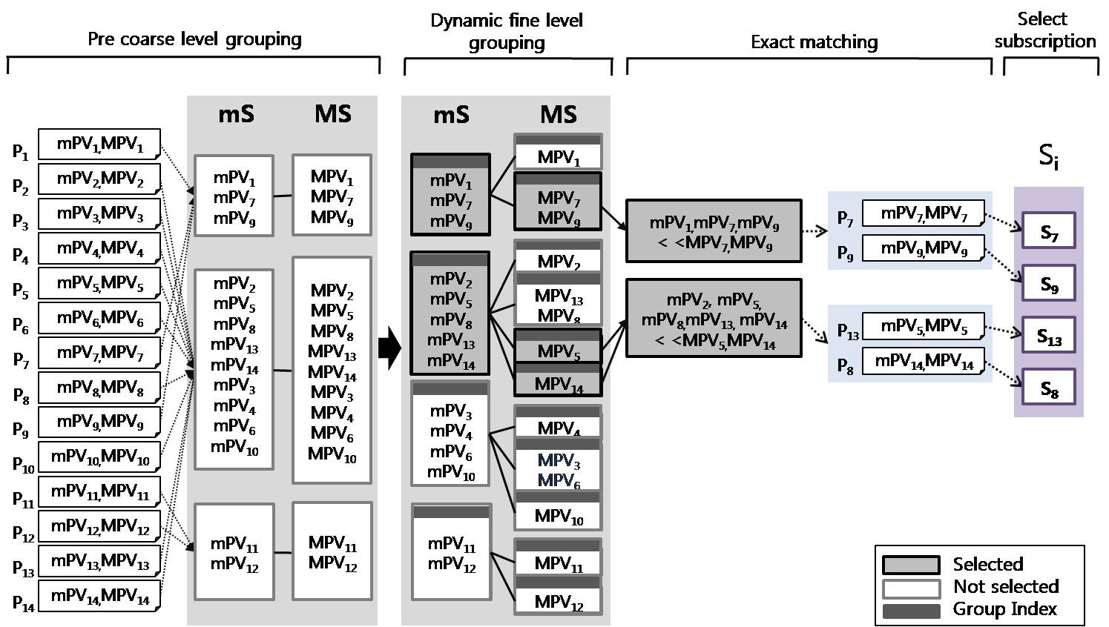
(Figure 21) CGIM procedure of matching algorithm

Performance evaluation
In this section, we examined our CGIM algorithm on the u-Health care system with various scenarios. However, as the range of the human body conditions is within boundary, consumer’s interest (expressed in subscription) is also within reasonable boundary. The figure 22 shows the subscription’s distribution of body temperature for the experiments submitted by nurses, staffs and doctors.

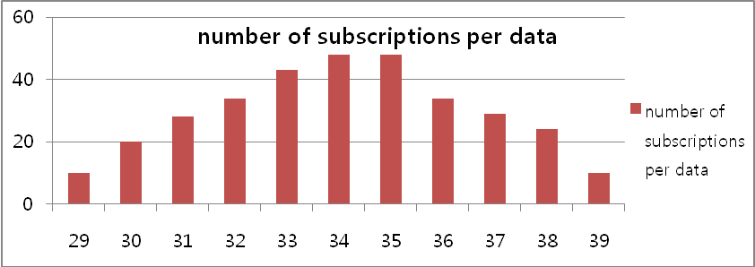
(Figure 22) The numbers of subscriptions per data

Performance comparison

The basic partitioning idea from statistics is employed to decide the number of class for mS and MS (denoted to m and M, respectively) by m=1+log₂ n(mS), and M=log₂ n(MS), where n(mS) is the number of element in the set, mS. The statistical grouping (denoted to SG) method decides an equivalent interval of each class by (y-x)/m and (Y-X/M) for mS and MS, respectively. Figure 23 shows the detail of partitioning method in (a) and distribution of groups in (b).
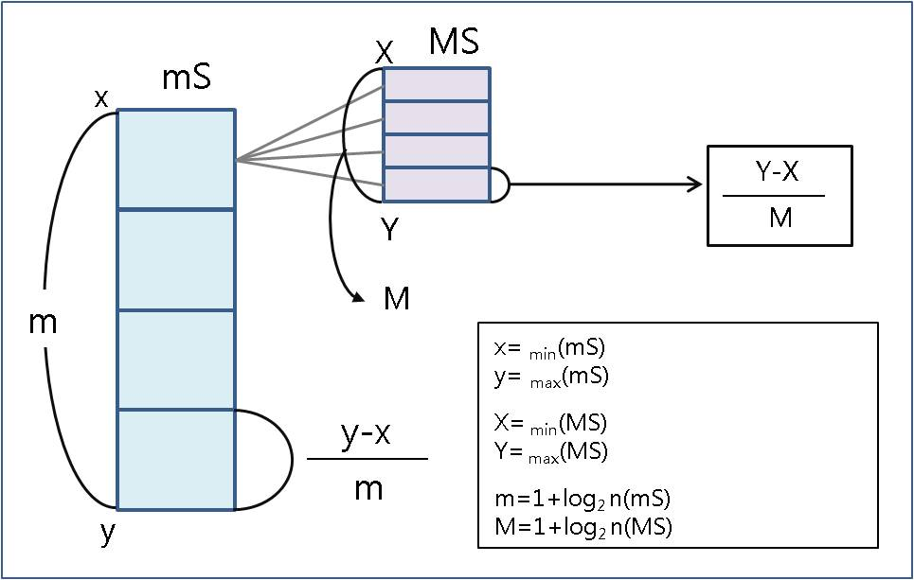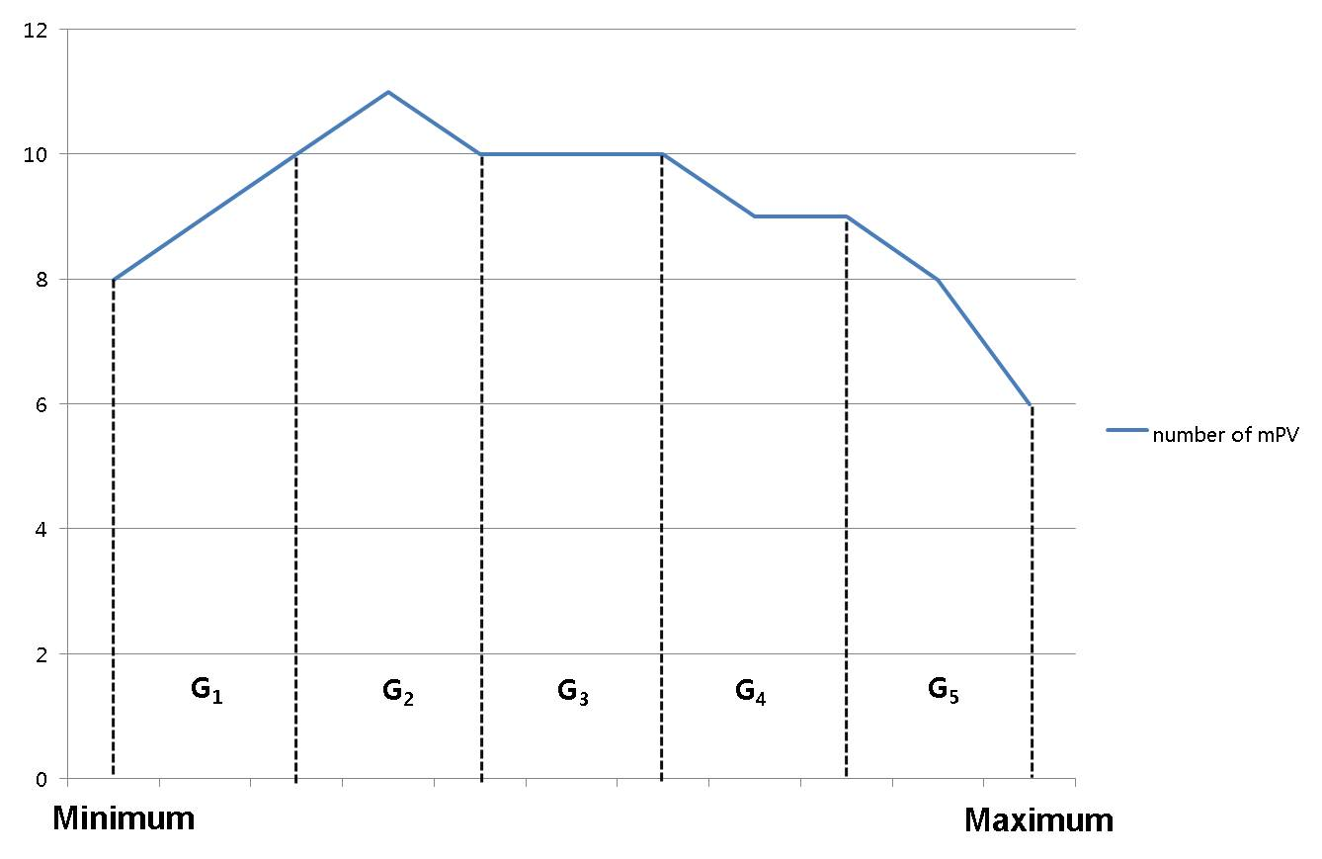
(a) grouping method (b) distribution of groups

(Figure 23) Conventional statistical fixed interval partitioning

The pub/sub system needs to handle various cases of predicate expressions for diversity of subscribers. As we mentioned, three different cases are employed in CGIM. In the following experiments, we conduct performance comparison with three previous algorithms. The algorithms are described as follows;

(1) Worst case (Sequential matching): If sensor data reaches the system, Sequential matching matches all subscriptions with the data sequentially.
(2) Forwarding algorithm: The forwarding algorithm matches data to subscriptions that include a single predicate. It groups predicates using attributes and operators, and indexes the values of predicates. This algorithm results in two groups of predicates by matching two operators and finds correct predicates by combining the two results
(3) Best case (Optimal matching): it matches data with subscriptions optimally.

As we mentioned, three different predicate cases are examined in the above schemes. The experiment for each case is explained as follows.

- Case 1: mPV < data < MPV
The following experiment shows the total comparison using three algorithms and CGIM. The figure 24 shows the matching comparison of the CGIM algorithm with different numbers of groups and three algorithms with five sensed data for the predicate case 1. The worst case and the forwarding algorithm match “minimal value<data” and “maximum value>data” separately using indexing predicates and combine the results. The matching comparison is computed by 1000 for the worst case and 646 for the forwarding algorithm, while the proposed CGIM requires only 273 matches in total.

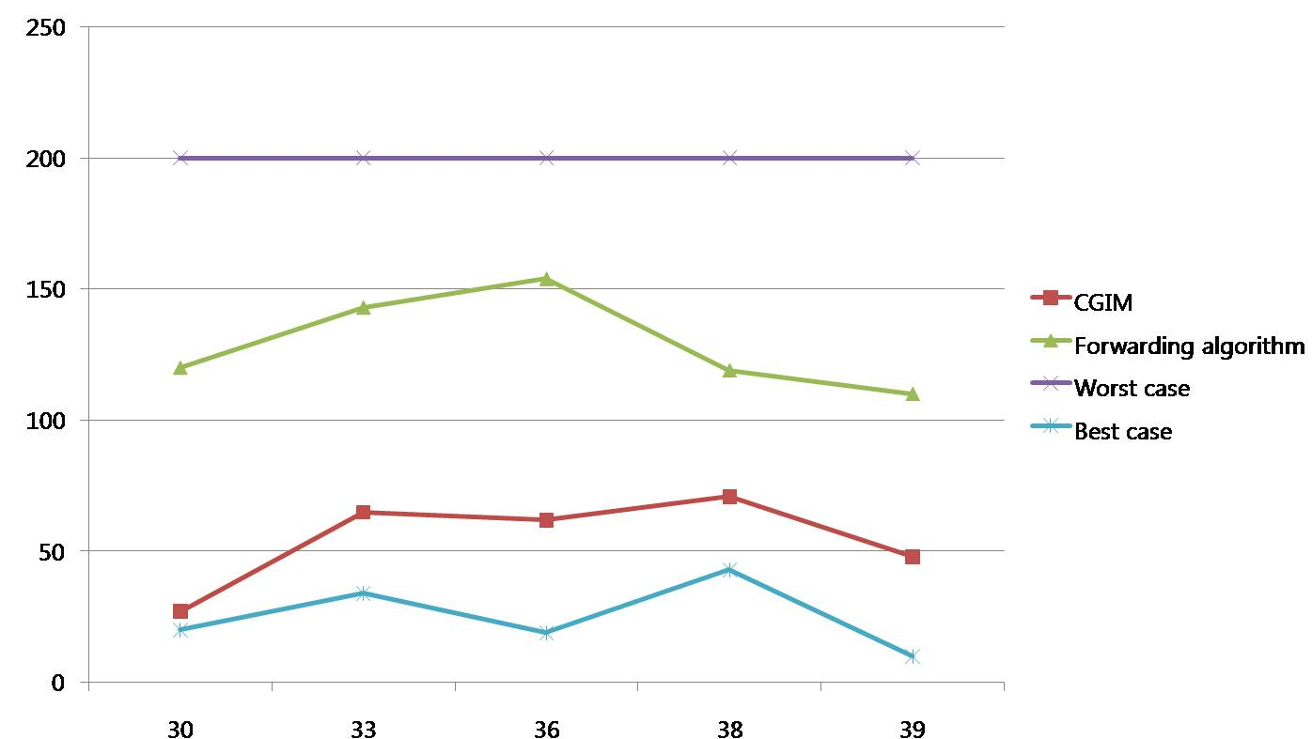

(Figure 24) Matching for the predicate case 1

So the additional comparison is calculated by 874 for the worst case, 520 for the forwarding algorithm, and 147 for the CGIM (where additional matching time = each algorithm matching comparison - best case matching comparison). Thus, the CGIM can reduce wasted matching time for the worst case and the forwarding algorithm by 83% and 71%, respectively.

- Case 2: mPV>data || MPV<data
This experiment is done for the predicate case 2 under the same condition as the predicate case 1. The figure 25 shows the matching comparison of the CGIM algorithm with different numbers of groups and three algorithms. The comparison is computed by 1000 for the worst case, and 284 for the forwarding algorithm. The proposed CGIM requires 446 matches on average. In this case, the forwarding algorithm performs better than the CGIM algorithm. But, it requires more space for indexing all predicate values, while CGIM makes an index for groups. If we index all sub-predicates, equivalent performance will be measured.

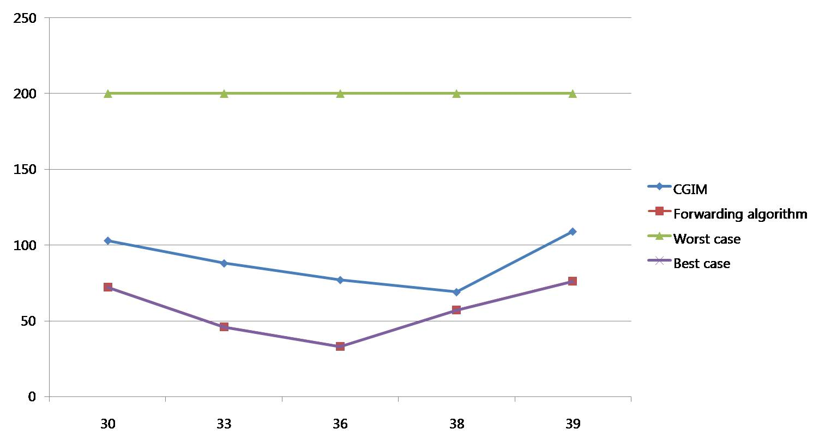
(Figure 25) Matching for the predicate case 2
- Case 3 : mPV>data1 && MPV<data2
This experiment is designed for matching of multiple events with two sensed inputs. In this experiment, we measured the total matches with four pairs of subscriptions such as (mPV=29>data1, MPV=38<data2), (mPV=29>data1, MPV=33<data2), (mPV=33>data1,MPV=37<data2), and (mPV=32>data1,MPV=35<data2). As shown in the figure 26, the matching comparison is counted by 1000 for the worst case and 364 for the forwarding algorithm, while the proposed CGIM requires only 197 matches on average. The CGIM can reduce wasted matching comparison for the worst case and the forwarding algorithm by 80% and 46%, respectively.

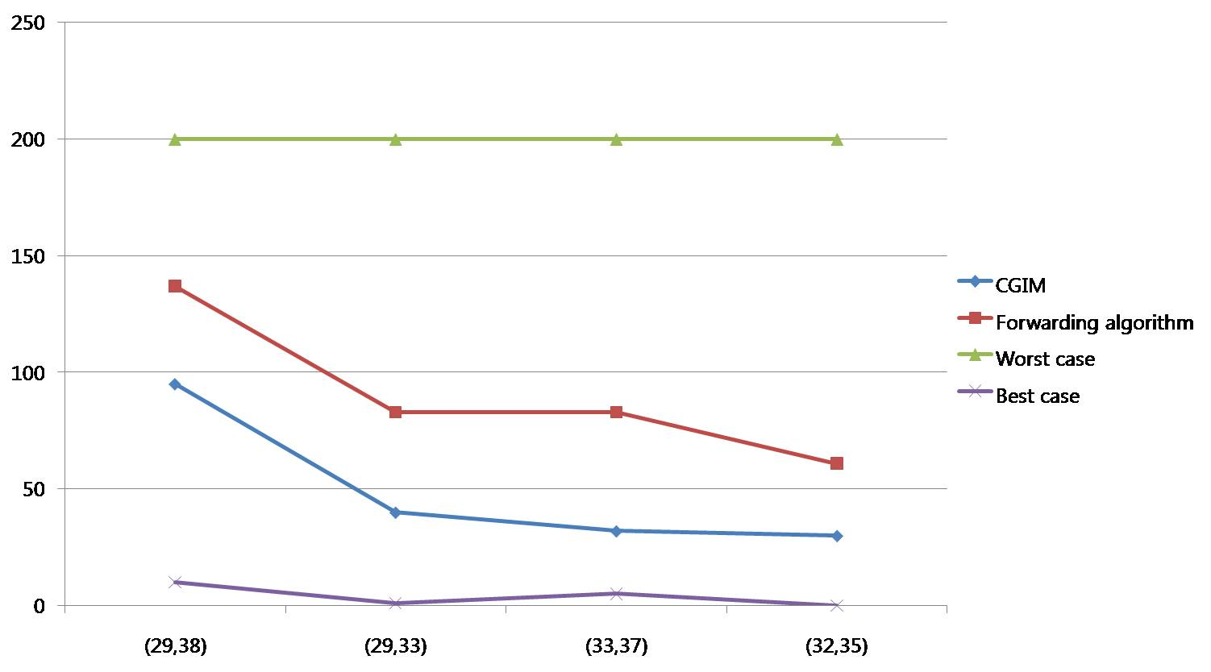
(Figure 26) Matching for the predicate case 3

Impact of grouping

As seen from the above experiments, statistical based CGIM performs better than previous work especially for case 1&3. However, different statistical distribution of subscriptions may result in different matching performance. In this section, we analyze statistical metrics of subscription distribution with various types of predicates and suggest two efficient grouping methods.
For grouping for the case 1, we examined 50 subscriptions for 3 sensed data (data=30, data=36, data=38) on the statistical grouping scheme and user defined number of groups. The figure 27 shows the result of our examination.

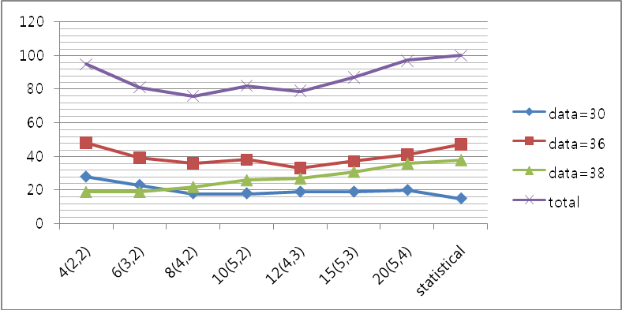
(Figure 27) Event triggering with various numbers of classes
From the figure 27, we found that CGIM performs well and a different number of classed groups affect matching performance. The x axis in figure 27 shows the different number of classed groups. The “10(5,2)” indicates 5 predicates in each mS set, 2 predicates in each MS set, and 10 means total number of groups. In this statistical approach, 7 predicates are equally assigned to each class.
According to the figure 27, searching time also depends on 2 factors: input data and the number of groups. If sensed data has a very low or high value, the matching will go through to the end of the group by traversing the tree as shown in the BDD model. Also, the number of predicates in a class affects comparison time.

5.2.1 Statistical approach to Dynamic Re-Grouping (DRG)
As shown in the figure 27, it is important to decide the proper number of groups to improve performance. In this section, we analyzed the characteristics of subscription distribution, and then found that more centralized mS and MS distributions to mode (most frequently appeared sample) need sub-divided groups with different interval size, while traditional approaches use an equivalent interval for all the samples. Thus, depending on kurtosis, the number of classed groups is analyzed as follows.

According to kurtosis, as shown in the figure 28, it divides whole range into three groups. The range of the first group is larger than the minimum value of the subscription and is smaller than α. The second groups’ range is larger than α and smaller than β, and the range of the rest is larger than β and smaller than the maximum value of mS or MS. After that, the second group is divided to subgroups, and the number of groups (i.e. G2, G3, G4) is calculated by the statistical method shown in the figure 23. For the re-grouping, statistical metrics are considered as follows:
α= Mode - Standard deviation
β= Mode + Standard deviation

The figure 28 shows how dynamic re-grouping is produced in our scheme.

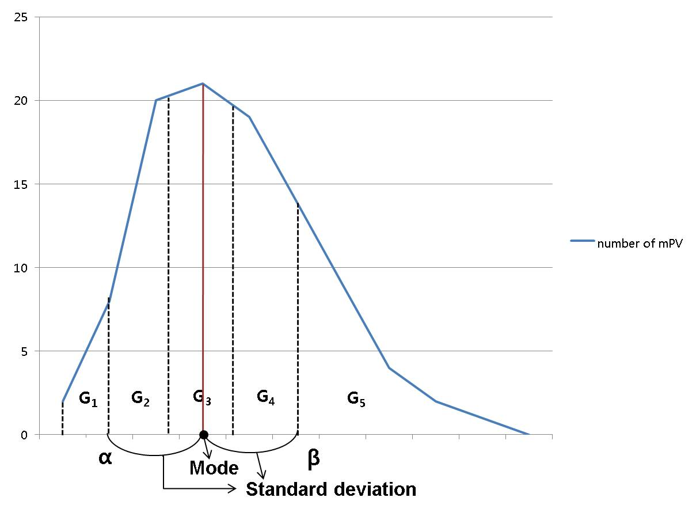
(Figure 28) Dynamic re-grouping approach
From the experiment, the fixed & equivalently sliced interval for groups is efficient on low kurtosis. This might be useful for subscriptions distributed uniformly. But, the DRG method is efficient when kurtosis of subscription distribution is high. In order to verify the efficiency of dynamic re-grouping rather than the conventional SG approach, we compared them with same number of groups in case of normal subscription distribution.

(Table 1) DRG matching performance

group numbers | 29 | 31 | 32 | 33 | 35 | Total performance
4 | 10 | 26 | 81 | 81 | 104 | 302
5 | 10 | 26 | 57 | 82 | 105 | 280
6 | 10 | 27 | 58 | 83 | 106 | 284
Best_case | 3 | 26 | 53 | 77 | 98 | 257

(Table 2) SG matching performance

group numbers | 29 | 31 | 32 | 33 | 35 | Total  performance
4 | 26 | 26 | 80 | 80 | 100 | 312
5 | 10 | 56 | 56 | 93 | 103 | 318
6 | 10 | 56 | 56 | 93 | 101 | 316
Best_case | 3 | 26 | 53 | 77 | 98 | 257

From table 1&2, the group with different intervals in DRG performs better than groups with equivalent interval in SG, even though same number of groups is applied. The average number of matching from the table 1&2 is computed by 315 for the SG and 288 for the DRG.

According to the result of table 1&2, we simulated additionally to find how much the DRG is more efficient than the SG with various subscription distribution types. The types of subscriptions are classified by kurtosis. The examples of subscription patterns are described in table 3.

(Table 3) Example of the subscription distribution pattern

Subscription Type | Type 1 | Type 2 | Type 3 | Type 4 | Type 5
Kurtosis | 2 | 2.5 | 3 | 3.5 | 4
Skewness | 0.232812 | 0.406678 | 0.1255 | 0.642479 | 0.490915
Standard deviation | 2.989865 | 2.557046 | 1.489221 | 1.5 | 1.623191
variance | 8.939293 | 6.538485 | 2.217778 | 2.25 | 2.634747
Average | 32.51 | 31.87 | 31.38 | 31.25 | 31.54
Mode | 31 | 31 | 31 | 31 | 31
We calculated efficiency of the DRG by comparing to the SG performance as shown in table 4. The numbers in column of table 4 means additional comparisons against the optimal (best) case.

(Table 4) Efficiency of the DRG

Subscription Type | Type 1 | Type 2 | Type 3 | Type 4 | Type 5
DRG overhead | 16 | 4 | 4 | 5 | 4
SG overhead | 48 | 22 | 24 | 58 | 31
Compared DRG efficiency | 66.70% | 81.90% | 83.40% | 91.40% | 87.10%

5.2.2 Performance Prediction

Various subscription distributions will deliver different matching performance at any matching schemes. In this subsection, we illustrate efficiency prediction on various subscriptions using DRG. From the shaded results (kurtosis, efficiency) in table 5, we derived the formula of the efficiency by using linear regression to estimate efficiency as shown in table 5 and figure 29.

(Table 5) Estimation of efficiency

Kurtosis | efficiency (%)
0 | 51.92
0.5 | 56.95
1 | 61.98
1.5 | 67.01
2 | 66.7
2.5 | 81.9
3 | 83.4
3.5 | 91.4
4 | 87.1
4.5 | 97.19
5 | 98.482

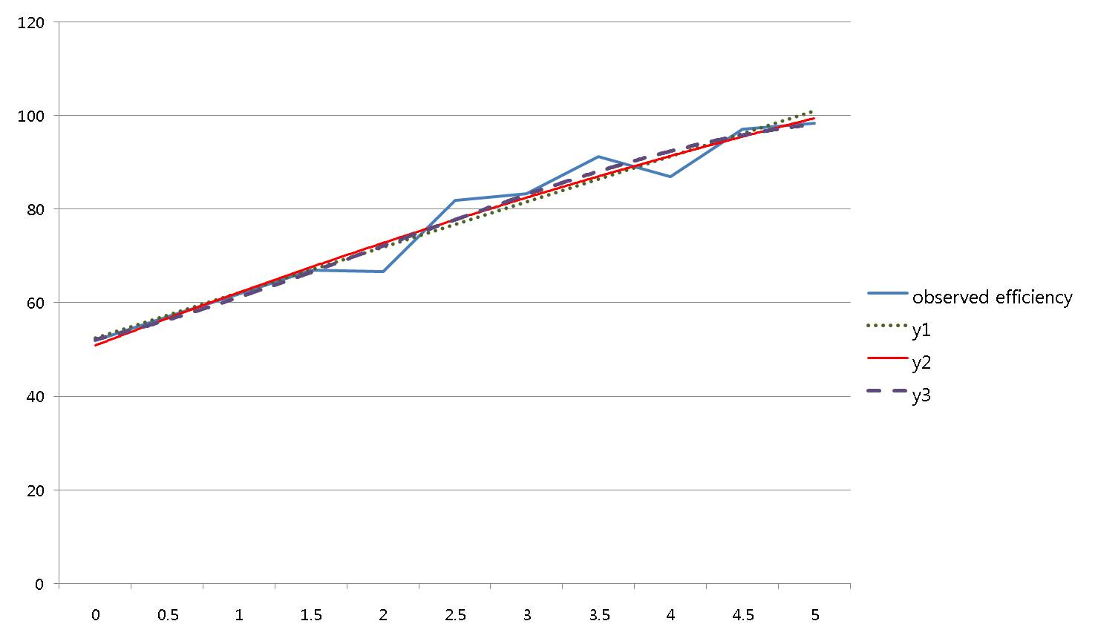
(Figure 29) The observed efficiency and trend lines
We examined three formulas to find more accurate estimation as shown in figure 29. The first formula employing a one dimensional linear equation, y1 = 4.860x + 47.57, brings 96% accuracy. The second formula employing a quadratic equation, y2 = -0.103x² + 6.098x + 44.88, corresponds to 97% accuracy. The third formula applying cubic equation, y3 = -0.037x³ + 0.568x² + 2.734x + 48.95, corresponds to 96% accuracy.

Conclusion
In this document we proposed the ARROW architecture that integrates sensor network and Grid for information dissemination. The ARROW supports a gateway between sensor network and Grid to process and manage huge amount of data, provide interfaces for consumers, and employ the pub/sub system. An efficient matching algorithm called CGIM designed by considering three types of predicate conditions, and reduces matching overhead significantly. The following contributions are a summary of the experiments:
1) Provision of time and event driven delivery
2) Allowing multiple events using event acquisition queue
3) Flexible expression for diverse consumers
4) Efficient dynamic re-grouping based on statistical distribution of subscription
5) Prediction of matching efficiency using DRG

Author Information
Eui-Nam Huh
Kyung Hee University
Korea
Johnhuh@khu.ac.kr

Pill-Woo Lee
KISTI
Korea
pwlee@kisti.re.kr

Bo-Hyun Seok
Kyung Hee University
Korea
bohyun@icns.khu.ac.kr

Intellectual Property Statement

The OGF takes no position regarding the validity or scope of any intellectual property or other rights that might be claimed to pertain to the implementation or use of the technology described in this document or the extent to which any license under such rights might or might not be available; neither does it represent that it has made any effort to identify any such rights. Copies of claims of rights made available for publication and any assurances of licenses to be made available, or the result of an attempt made to obtain a general license or permission for the use of such proprietary rights by implementers or users of this specification can be obtained from the GGF Secretariat.

The GGF invites any interested party to bring to its attention any copyrights, patents or patent applications, or other proprietary rights which may cover technology that may be required to practice this recommendation. Please address the information to the GGF Executive Director.

Full Copyright Notice

Copyright (C) Global Grid Forum (2007). All Rights Reserved.

This document and translations of it may be copied and furnished to others, and derivative works that comment on or otherwise explain it or assist in its implementation may be prepared, copied, published and distributed, in whole or in part, without restriction of any kind, provided that the above copyright notice and this paragraph are included on all such copies and derivative works. However, this document itself may not be modified in any way, such as by removing the copyright notice or references to the GGF or other organizations, except as needed for the purpose of developing Grid Recommendations in which case the procedures for copyrights defined in the GGF Document process must be followed, or as required to translate it into languages other than English.

The limited permissions granted above are perpetual and will not be revoked by the GGF or its successors or assigns.

This document and the information contained herein is provided on an "AS IS" basis and THE GLOBAL GRID FORUM DISCLAIMS ALL WARRANTIES, EXPRESS OR IMPLIED, INCLUDING BUT NOT LIMITED TO ANY WARRANTY THAT THE USE OF THE INFORMATION HEREIN WILL NOT INFRINGE ANY RIGHTS OR ANY IMPLIED WARRANTIES OF MERCHANTABILITY OR FITNESS FOR A PARTICULAR PURPOSE."

This document and the information contained herein is provided on an “As Is” basis and the OGF disclaims all warranties, express or implied, including but not limited to any warranty that the use of the information herein will not infringe any rights or any implied warranties of merchantability or fitness for a particular purpose.

References
1. Salman AlSairafi et al. Michelle Osmond, Anthony Rowe, Jameel Syed, Patrick Wendel, “THE DESIGN OF DISCOVERY NET: TOWARDS OPEN GRID SERVICES FOR KNOWLEDGE DISCOVERY”, The International Journal of High Performance Computing Applications, Volume 17, No. 3, Fall 2003, pp. 297–315

2. R. Bramley et al. "Instruments and sensors as network services: Making instruments first class members of the grid". Technical Report 588, Indiana University CS Department, December 2003.

3. Hock Beng Lim, et al. "Sensor Grid: Integration of Wireless Sensor Networks and the Grid", Proceedings of the IEEE Conference on Local Computer Networks 30th Anniversary (LCN’05)

4. Chen-Khong Tham et al, "SensorGrid: Integrating Sensor Networks and Grid Computing", CSI Communications, pages 24-29, Vol.29, No.1, ISSN 0970-647X, Computer Society of India (CSI), Mumbai, India, July 2005.

5. Zubair A. Baig et al, "SGSIA-In-Network Data Preprocessing for Secure Grid-Sensor Integration", Proceedings of the Second IEEE International Conference on e-Science and Grid Computing (e-Science'06)

6. Ioana Stanoi et al, “A Framework for the Selective Dissemination of XML Documents based on Inferred User Profiles”, Proceedings of the 19th International Conference on Data Engineering (ICDE’03)

7. Gero Mühl et al,” Disseminating Information to Mobile Clients Using Publish–Subscribe”, Vol. 8 ,46-53, 2004, ISSN:1089-7801,IEEE Internet Computing

8. Open Grid forum, “http://www.ogf.org”

9. Vijay Dialani, Ronny Fehling et al. “INFOD Base Specification”, www.ogf.org

10. Jaturon Chattratichat et al, "A Visual Language for Internet-Based Data Mining and Data Visualization, Proceedings of the IEEE Symposium on Visual Languages table of contents, 1999, ISBN:0-7695-0216-4
11. “INFOD Patterns”, www.ogf.org.

12. “INFOD_Base_Use_Case_Scenarios_for_GGF16”, www.ogf.org

13. “www.ogsadai.org” , OGSA-DAI

14. Marcos K. Aguilera et al, Matching Events in a Content based Subscription System, Proceedings of PODC, May 1999

15. Gang Xu et al, An Extended Event Matching Approach in Content-based Pub/Sub Systems for EAI, Proceedings of the 2005 Ninth IEEE International EDOC Enterprise Computing Conference (EDOC’05)

16. Ghazaleh Ashayer et al, Predicate Matching and Subscription Matching in Publish/Subscribe Systems, Proceedings of the 22 nd International Conference on Distributed Computing Systems Workshops (ICDCSW’02)

17. Antonio Carzaniga Alexander L.Wolf, “Fast Forwarding for Content-Based Networking”, Technical Report CU-CS-922-01, Department of Computer Science, University of Colorado, November, 2001. Revised, September 2002.

18. Antonio Carzaniga, Alexander L. Wolf, “Forwarding in a Content-Based Network”, Proceedings of ACM SIGCOMM 2003. p. 163-174. Karlsruhe, Germany. August, 2003.

